Enhancing Ice Storm Detection from the New York State Mesonet

Jacob Shultis

Mentor: Junhong Wang

Intense freezing rain/drizzle events lead to extremely hazardous conditions which can last up to days or weeks, causing large amounts of damage to property and infrastructure over their duration. This work attempts to gather a more high-resolution picture of ice storm spatial coverage, as well as duration of freezing effects, utilizing the data collected from the New York State Mesonet (NYSM). NYSM consists of 126 stations across the state collecting measurements of multiple meteorological variables, as well as images every five minutes. NYSM is the first network operationally making 10-m wind measurements from two independent sensors: propeller wind monitor and sonic anemometer. During ice storm events, large wind speed differences would be reported between propeller and sonic anemometers. With visits from NYSM’s field technicians, it was revealed that the propeller had developed a coating of ice, thus either completely stopping its spinning, or slowing it drastically. Looking at the winter of 2017-8, data was analyzed across all stations that reported similar wind speed differences to create an algorithm to detect freezing events with more rigor. It was found that along with wind speed differences, a temperature threshold can also be drawn to more accurately label an event as freezing rain. Looking at a case from April 14-16 2018, it was seen that using this method to detect freezing rain vastly improved the spatial extent of freezing rain than what was reported. This information is incredibly important for the public, and may be used to make better decisions in the future.

1) Introduction

1.1) Background

All across the United States, winter weather has a strong impact on economy, infrastructure, and people’s daily lives. One winter weather phenomena which has an enhanced risk of damage associated with them are ice storms. These intense freezing rain/freezing drizzle events lead to extremely hazardous conditions which can last up to days or weeks, causing large amounts of damage to property and infrastructure over their duration (Degelia et al. 2016). The impacts they can have range from minor traffic accidents to power outages to closure of air travel. The most effected by such storms are the power, transportation, aviation, public safety, and insurance industries. These dangerous storms have been seen to occur most commonly in the Northwest, North Central, and Northeast United States, with the highest frequency within the Northeast (Degelia et al. 2016). This paper will focus primarily on New York state and the ice storm threat therein.

1.2) Formation Processes

Freezing rain/Freezing drizzle forms through two primary ways: supercooled warm rain processes, and the melting process (Degelia et al. 2016). In the supercooled warm rain processes, droplets are formed via collision and coalescence within a sub-freezing environment and remain sub-freezing all the way to the surface where they freeze on contact with whatever surface they impact. In contrast, the melting process occurs when ice crystals fall through a layer of air aloft which is above freezing, allowing the crystals to melt before falling through a shallow sub-freezing layer near the surface. In this sub-freezing layer, the now liquid droplets become supercooled and freeze on contact with the surface, which must also be sub-freezing (Degelia et al., 2016).

These processes can occur due to frontal boundaries, as well as due to topographical features (Rauber et al. 2001). Winter warm fronts have a strong freezing rain threat due to their shape. As warm air pushes into a region, it moves up and over surface cold air which may be sub-freezing, thus creating the necessary conditions for freezing rain. As any liquid droplets fall from the warmer air aloft into the sub-freezing air below, they may become supercooled and lead to ice accumulation upon colliding with the surface. A more rare case are arctic fronts, which push very cold air down from the north in high latitudes, forcing the relatively warmer air to move up and over top the colder air. This forcing is typically associated with freezing drizzle due to the relatively weak strength of the forcing, but if it is strong enough, freezing rain can form behind the frontal boundary. Lastly, topography can play a role in forcing freezing rain by trapping cold air against mountain sides or in valleys. As warmer air flows over the top of the trapped cold air, freezing rain conditions can develop if precipitation forms within that region.

1.3) Frequency of occurrence

A close up of a map

Description generated with high confidence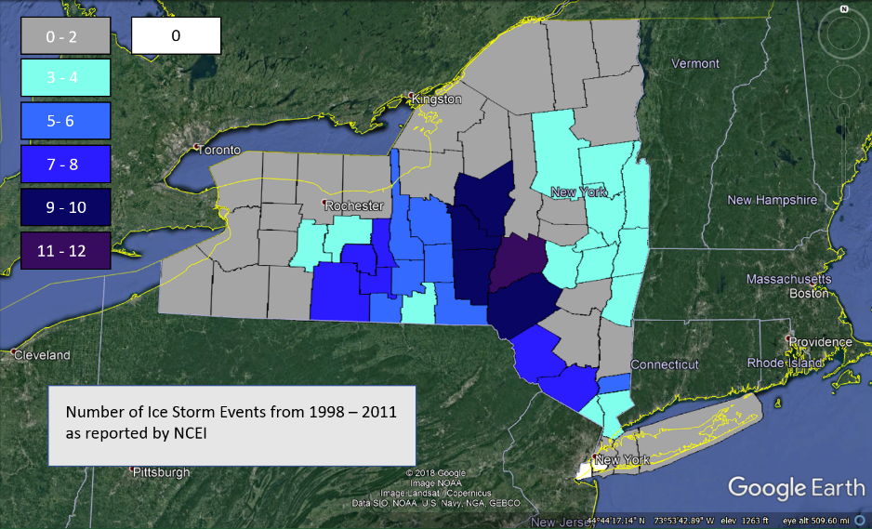As was previously stated, the Northeast experiences the highest frequency of ice storms within the entirety of the United States. Figure 1 is adapted from Kovacik and Kloesel (2014) studying ice storms across the United States, where a clear maximum in frequency is seen over the Northeast region (Kovacik and Kloesel, 2014). We analyzed the ice storms documented in National Oceanic and Atmospheric Administration’s (NOAA) National Centers for Environmental Information’s (NCEI) Storm Events Database (NCEI, 2019) and summarized the results in Figure 2. It shows a similar feature as Figure 1, with the highest frequency of ice storms over this time frame occurring in the Eastern Plateau region. This is due to the complex terrain which assists in creating freezing rain conditions as well as the frequency of frontal systems during the winter months. In the more recent timeframe, the state of New York has seen an increase in ice storm frequency during the last two decades (Fig. 1). From 1997-2018, there have been a total of 40 major ice storms recorded in the NOAANCEI Storm Events Database for the state of New York. These are listed below in table 1 and Fig 3. From these past events, the potential threat of ice storms is made prominent in the form of property damage. In 2003 alone, over $60 million in property damage was reported with direct correlation to ice storms. The April 4 – 5, 2003 ice storm was responsible for over $57 million of that total $60 million. This was due to the combination of ice and snow which fell together on a total of twenty eight counties for over two days, bringing down trees on homes, cars, electric lines, and other infrastructure. On the list, the second devastating ice storm occurred in January 1998 in both Northern NYS and New England (Degaetano 2000). The conservative estimate of total ice storm related damages exceeded 1 billion (Degaetano 2000). Looking at the temporal distribution of ice storms, it can be seen that there is a clear gap in activity for three years from 2013 – 2016. This gap may be due to large scale climatological circulations, but this theory was not investigated in this work.

Fig 1. The total number of documented ice storms across the U.S. between the winters 1966-1977 (top) and 1998-2011 (bottom). The Northeast experienced the highest frequency during both periods with a westward shift evident. (Kovacik and Kloesel, 2014)

Fig 2. Number of Ice storms over New York between the years 1998 – 2011 as reported by NCEI

Table 1. Total number of freezing rain days, associated dates, total number of counties/zones impacted within New York State, and property damage as reported by NCEI

|  |  |  |  |  |
| --- | --- | --- | --- | --- |
| Year | Number of Days | Dates | Counties/zones Impacted | Property Damage |
| 1997 | 2 | 3/14, 12/22 | 6 | $ 72,000 |
| 1998 | 3 | 1/6, 1/8, 1/15 | 14 | $ 23,000,000 |
| 1999 | 2 | 1/1, 1/3 | 20 | $ 0 |
| 2000 | 2 | 2/13, 12/14 | 21 | $ 0 |
| 2001 | 4 | 2/16, 2/24, 2/25, 3/12 | 21 | $ 0 |
| 2002 | 4 | 1/31, 3/26, 11/16, 11/17 | 20 | $ 7,085,000 |
| 2003 | 4 | 1/1, 2/23, 4/4, 4/5 | 28 | $ 60,300,000 |
| 2005 | 1 | 12/16 | 1 | $ 0 |
| 2007 | 4 | 1/13, 1/15, 2/13, 3/2 | 39 | $ 0 |
| 2008 | 5 | 2/1, 2/13, 3/4, 3/7, 12/11 | 36 | $ 25,000 |
| 2009 | 2 | 1/6, 12/25 | 3 | $ 0 |
| 2011 | 2 | 2/1, 3/6 | 10 | $ 0 |
| 2012 | 1 | 1/12 | 3 | $ 65,000 |
| 2013 | 2 | 12/20, 12/21 | 15 | $ 4,250,000 |
| 2017 | 1 | 2/7 | 7 | $ 0 |
| 2018 | 1 | 4/14 | 12 | $ 205,000 |

A picture containing screenshot

Description generated with high confidence

Fig 3. Total number of freezing rain days and counties effected per year according to NCEI. Maximum days per year with Ice storms: 5 in 2008. Maximum counties effected in a single year: 39 in 2007.

1.4) Freezing rain measurements

Until currently, the primary method of recording freezing rain evens has been through the Automated Surface Observing System (ASOS). This network consists of a total of 27 observing sites across New York State (Fig. 4), which all have a dedicated sensor to measure freezing rain. This sensor works by measuring the frequency of a vibrating probe, which during freezing rain events will slow down due to the accretion of ice. This reduction in frequency is then recorded as freezing rain as long as the ambient temperature is below a certain threshold and snow is not the primary form of precipitation (ASOS, 1998). The problem that one runs into when utilizing ASOS data however, is the spatial coverage. Due to the fact that there is only 27 sites within the entirety of New York State, there is large areas of the state left completely reliant on county emergency services for reports of ice storms and freezing rain (Fig. 4). This motivates a need for a high spatial coverage system which can gather measurements for freezing rain events within New York State.

The New York State Mesonet (NYSM) offers a solution to the spatial coverage problem associated with ASOS. With a total of 126 stations throughout New York State separated into ten distinct climate regions, each with average displacement of 30km between stations, the NYSM is a valuable asset in analyzing past and ongoing storms of all kinds (Fig. 4). This difference between NYSM and ASOS is shown in Fig 4. A 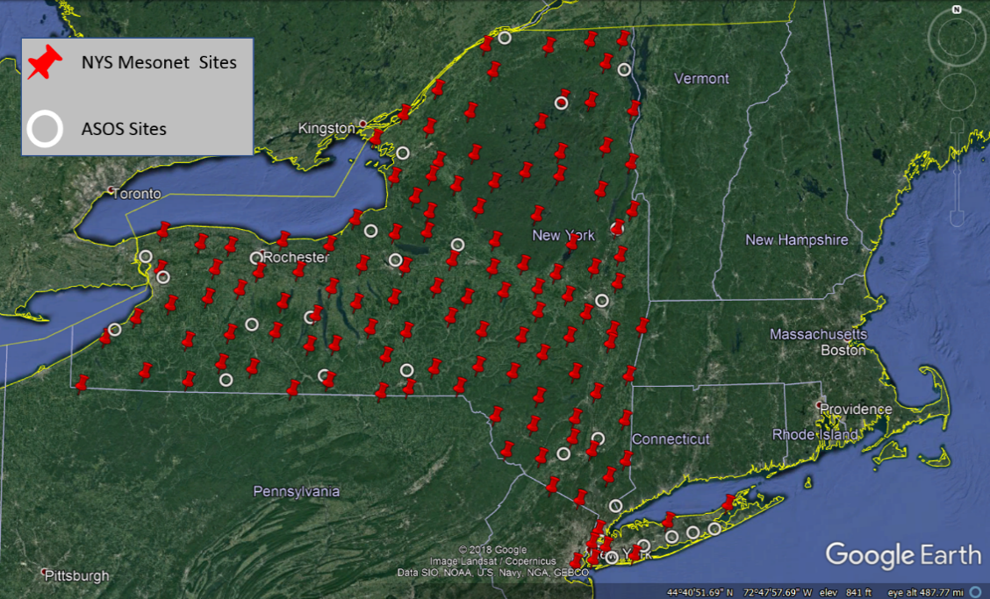normal station is equipped with two air temperature sensors at 2m and 9m, hygrometer at 2m, both sonic and propeller anemometer for wind speed/direction, a weighting rain gauge, soil temperature/moisture sensors at 5,25, and 50cm below the ground, barometer for pressure measurements, pyranometer for solar radiation measurements, and finally a snow depth sensor. All of this data is recorded in five minute intervals, making it also temporally higher resolution than ASOS. There is also a total of 17 profiler sites spread across New York State which utilize a LiDAR, microwave radiometer, and an environmental sky imager – radiometer. All of these instruments coupled with the spatial and temporal coverage of the NYSM make up an advanced network for studying small scale weather systems, however there is not a dedicated freezing rain sensor equipped on any station. Instead, an observation has led to a potential way to verify ice storms with only the sensors equipped currently.

Fig 4. NYSM site coverage compared to ASOS site coverage over New York State.

1.5) Scientific Questions

With all of this introductory information presented, some questions to attempt to answer can be drawn. First, is it possible to detect freezing rain utilizing the NYSM as it is equipped currently? If so, is it possible to enhance detection and eliminate false cases utilizing other parameters monitored by the NYSM? Finally, what sort of advantages does this method have to give to the community? It is the goal of this work to answer these questions and more.

2.0) Methodology

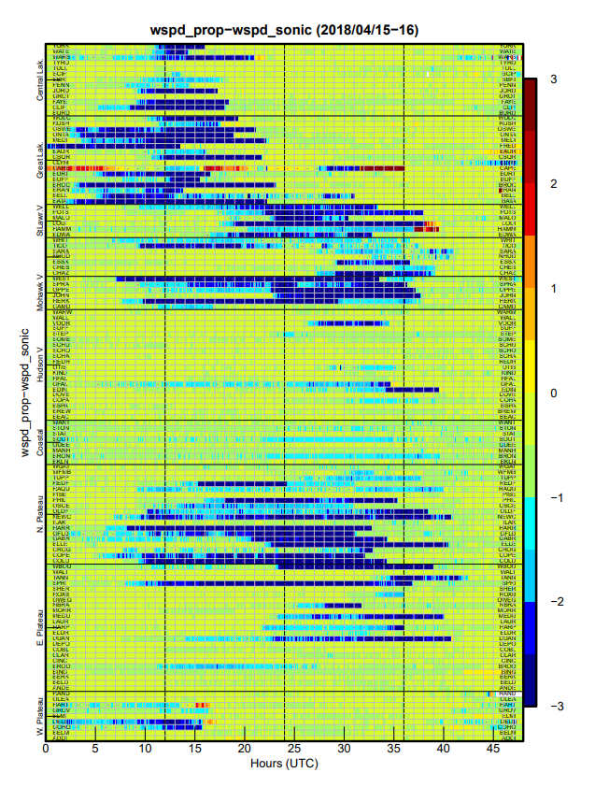The methodology for this study was directly developed based off of repeated observations from across the NYSM by both observers within the NYSM operations center and field technicians working at sites. It was seen that during periods of winter weather, the automatic quality assurance program used in house at the NYSM would flag wind speed data for varying durations based off differences in reports from the propeller wind monitor and sonic anemometer exceeding 1m/s. From observers at the NYSM operations center utilizing the cameras placed at each site, it was seen that these durations of flagged wind speed data corresponded with some form of precipitation falling. As these events became more regular, field technicians were sent out to investigate the cause of the differences, where it was discovered that freezing rain had accumulated ice on the propeller wind monitor, causing it to slow heavily or even stop spinning entirely. From then on, the NYSM has kept record in house of every site which reports the propeller slowing/stopping due to observed freezing rain. Until this work, the requirements to flag an event as freezing rain consisted of wind speed differences greater then 1m/s or propeller reporting exactly 0m/s while sonic continued to measure, and visually observed liquid precipitation on the camera at the site. Fig 5 is an example of a freezing rain event as presented by wind speed differences per station, this plot is a first indicator to observers in the NYSM operations center that freezing rain may be slowing/stopping the propeller. The start time of an event was reported as the time where the propeller froze (reports 0 m/s) or where wind speed differences crossed the 1m/s threshold, and the end time was reported as the time when the propeller re-aligned with the sonic anemometer. In performing this research, a second variable was analyzed to attempt to add more rigor the freezing event flagging: air temperature at 9m. Fig 6 represents how a temperature threshold would fit into the freezing rain flagging process.

Fig5. Wind speed differences plot from the April 14 – 16 2018 freezing rain event. Each row is a single station, and blue indicates that station is reporting the propeller slowing/stopping

For this work, the winter season from November 2017 to April 2018 was analyzed since this was the first complete year of freezing rain event monitoring. By utilizing the inhouse database of freezing events including start/end date/time for this temporal domain, raw 5 minute resolution NYSM data could be read and analyzed specifically during the reported time for a specific site. Using this data, temperature at 9m, wind speed, wind speed difference, and more distributions were created to gather a detailed look at conditions during reported freezing rain events. This information was further analyzed by preparing a case study of the April 14 – 16 ice storm which struck New York in 2018. The results of this work are presented below.

Fig6. Schematic of flagging freezing rain events utilizing a potential threshold of temperature, temperatures outside of threshold would warrant further investigation

3.0) Results

3.1) Preliminary Freezing Rain Geographical Distribution

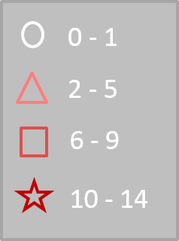To begin, the number of freezing rain reports per station was analyzed and is presented herein as Fig 7. From this, the same bullseye structure can be seen present over the Eastern Plateau/Catskills region as was in the NCEI climatology and Kovacik and Kloesel (2014). However some other interesting features can be seen within the geographical distribution. Most prominent is the local maximum in frequency over the Mohawk Valley. This region can trap cold sub-freezing air near the surface along the valley floor while warmer air flows up and over the Catskills, resulting in the formation of a melting layer. The other interesting feature shown here is the small scale maxima in Western New York off the Great Lakes. The spatial distribution here is much less clean, with some sites reporting 10+ events directly next to a site reporting 0-1 events. This could be due to the small scale nature of lake effect snow storms, where if temperatures are warm enough there is a chance to produce freezing rain associated with that distribution. One aspect of this distribution that seems strange is the high frequency of freezing rain events in the coastal region including New York City. Most likely some of the events in this region are not actually freezing rain events but still reported large enough wind speed differences to merit flagging. This is a prime example of why this methodology requires further parameters to limit outliers and false alarms.

Fig7. Freezing rain events per station for winter 2017 – 2018 as reported by the NYSM

3.2)Wind Measurements

The first condition that was checked during freezing rain events was wind speeds between the propeller wind monitor and sonic anemometer (Fig. 5). This was done to verify the underlying theory that the propeller physically slowed down or stopped in relation to the sonic anemometer as was reported by the raw data. Fig 8a is the distribution of propeller wind speeds compared to sonic wind speeds during all recorded freezing rain events in 2017-2018 winter. One of the big take-aways that can be seen is that the propeller reported completely freezing to 0m/s with a frequency over thirty percent. This reinforces the fact that the propeller freezing completely is not a rare or insignificant event, and is actually the most frequent case during freezing rain events. The left shift of the distribution of propeller wind speeds from sonic wind speed distribution further reinforces that these differences show up in a total sense. Fig 8b is a plot of wind speed differences as reported during freezing rain events. The clear peak at 1m/s lines up with the methodology since 1m/s was the threshold for flagging freezing rain events. Everything to the right of that threshold was picked up clearly by the automatic quality assurance program and allowed observers to flag the event. What is interesting in this plot is the distribution to the left of the 1m/s line. It was found that during some events the sonic anemometer dipped below 1m/s sustained wind speed while the propeller was frozen. This would then report a wind speed difference less than 1m/s even though freezing rain conditions were still present. These events were labeled weak wind events and added further scrutiny to the analysis process.

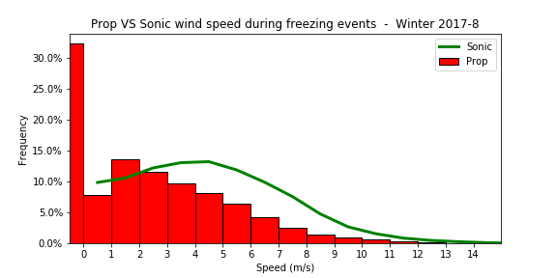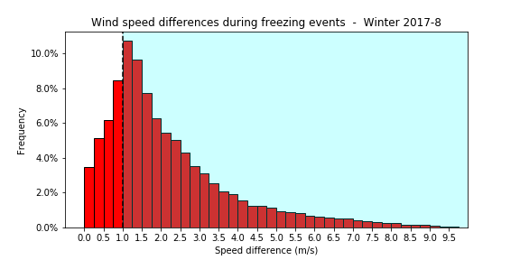

Fig8a. Wind speed frequency during freezing rain events from propeller and sonic

Fig8b. Wind speed difference frequency during freezing rain events, shaded region shows events that automated quality assurance picks up

3.3)Temperature Measurements

The variable that this work attempts to add as a degree of rigor is temperature as it was hypothesized that freezing rain conditions across New York would share some sort of temperature range. It was decided that temperature at nine meters would be the best measurement to use in this study since the wind measurement is also made at 9 m above ground level (AGL). When all of the nine meter temperature data was pulled for the duration of all reported freezing rain events during winter 2017 – 2018, Fig 9 was generated. The most obvious feature seen in the temperature distribution is the sharp cutoff at one degree Celsius. This makes logical sense to see since at temperatures close to 0°C, object surface temperatures can be below air temperature, meaning they would be sub-freezing and allow for ice accumulation if cooled liquid were to come in contact with that surface. Moving into the negative degrees Celsius, it can be seen that the distribution appears more normal with a more gentle decrease in frequency as colder temperatures are reached. With this gentler slope in mind, it is harder to find a left bound to a temperature threshold. It was then decided that by including only temperatures with frequency above five percent, a lower bound of negative five degrees Celsius can be drawn. This would then allow for the use of a temperature threshold from -5°C to 1°C .

Fig9. Temperature at 9m for all freezing rain events in winter 2017 – 2018. A clear threshold can be seen from -5°C to 1°C.

Another aspect of temperature measurements that was investigated was the evolution of temperature over the duration of freezing rain events. The goal of this was to investigate the tails of the temperature distribution, where temperatures in excess of two Celsius appeared as well as temperatures below negative five Celsius. To look at this, the same temperature data used previously was interpolated to normalize the time dimension of the dataset. This normalization would allow for the plotting of multiple temperature “profiles” where trends could be seen easily since each event would now have the same sized time dimension. This leads to the generation of Figure 10, where normalized time is on the Y axis and temperature at nine meters is plotted on the horizontal. Here each black line is the evolution of temperature at a single site from the start of the freezing rain event where the normalized time is zero to the end of that same event with the normalized time as 1 for the entirety of winter 2017 – 2018. Looking at the area with the largest concentration of profiles, it can be seen very clearly that these freezing rain events favor the negative five degrees Celsius A close up of a map
to one degree Celsius range of temperatures. Outliers can also be clearly seen in this view, with some sites starting at positive five degrees Celsius while others start at negative eight degrees Celsius. Focusing on the evolution of temperature now, it is seen from the mean profile that the evolution of temperatures during freezing rain events seem to favor a warming trend. This is also seen by the very small amount of sites above zero degrees Celsius at the beginning of their event, compared to the larger amount of sites above freezing at the end of their event. Linking this back to the tails of the previous temperature distribution, the right tail of the distribution would appear to mostly come from the end of freezing rain events where temperatures around two degrees Celsius are more common. Once again though, the left tail appears to be more messy, since there are colder outliers scattered throughout, this may be more geographically dependent, however this was not pursued.

Fig10. Normalized time (Y axis) versus temperature for each station during freezing rain events for the winter 2017 – 2018 period.

4.0)Case Study

To attempt to apply this work to a past case, the ice storm of April 14 – 16 2018 was chosen. This case was chosen because it was the largest freezing rain event of the year for New York State. Besides bringing freezing rain to New York, this same storm also developed blizzard conditions in the Midwest – Great Lakes region, while simultaneously developing supercells and tornadoes over the Texas – Louisiana region. The same event was attributed with large scale flooding along the Eastern Seaboard, earning the storm a place as one of the most diverse storms of the year. Back to the freezing rain in New York, over sixty NYSM sites reported freezing rain during the duration of the storm. This means the sample size for measurements was much greater than normal, giving a rare opportunity to really dive into the utilization of this methodology for measurement.

4.1)Synoptic Overview

The April 14 – 16 2018 winter storm was synoptically driven, originating to the west of the Rockies as a small surface low pressure center upstream of a standard trough at 12 UTC April 12. As time progressed and the surface low pressure center crossed the Rockies, the low intensified rapidly due to lee cyclogenesis off the mountains and reached a pressure of 985mb over Eastern Kansas by 12 UTC April 13. At this point however, the surface low pressure center stalled over Kansas, sitting in place while a stationary front stretched from the surface low pressure center all the way to the New England area. This lead to a massive temperature gradient spanning half of the country as seen in Fig 11. As the storm slowly tracked to the east, cold dense air from the north flowed down into the Northeast while very moist and warm air from the Gulf of Mexico flowed up and over the stationary boundary. This is what ended up leading to blizzard conditions in the west, but more importantly for this study it is the primary cause for the large scale freezing rain that was seen. With cold air at the surface flowing from the north, mid-level warm air advection from the south acted to generate a picture perfect melting layer set up for freezing rain over New York. By the morning of April 15, both Buffalo and Albany’s vertical soundings resembled freezing rain soundings as seen in Fig 12a and 12b. This lead to wide spread freezing rain to be seen across the state during this event.

Fig11. April 14 2018 at 12 UTC 850mb Temperatures C (fill), heights dam (contours), and winds kts (barbs) from GFS

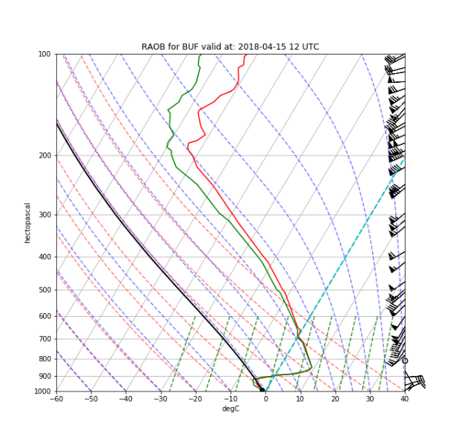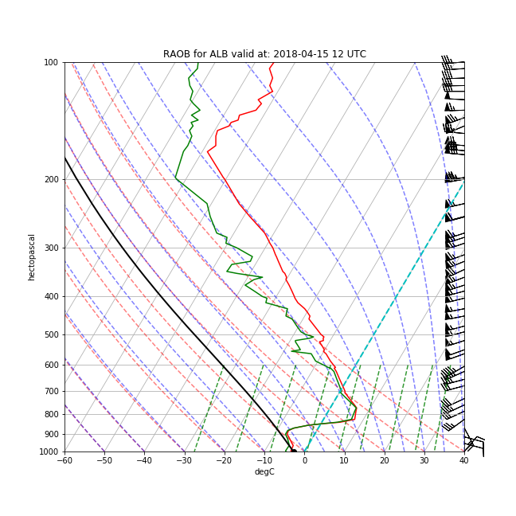

Fig12 a) RAOB for Buffalo b) RAOB for Albany, both taken at 12 UTC on April 15 2018

a

b

4.2)NYSM Impact

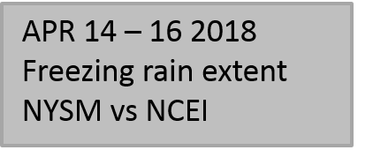In April of 2018, the NYSM was officially 100% operational, meaning all 126 sites were able to take measurements during this large event. As was previously stated, over sixty NYSM sites reported freezing rain signatures spanning April 14 at 23 UTC to April 16 at 18 UTC (Fig. 13). The major regions effected by freezing rain during this event according to the NYSM data were: the Great Lakes, Central Lakes, North Plateau, and East Plateau (Fig. 13). That said, all ten of the climate regions represented by the NYSM reported some amount of sites with freezing rain besides these major areas. Comparing these reports to the NCEI database for this event shows a very sharp difference. From Fig 13, NCEI shows freezing rain extent spanning the Great Lakes and the Northern Central Lakes regions only. The NYSM measurements in those regions reflect that extent as well, which is a good indicator that those sites are reporting wind speed differences between propeller wind monitor and sonic anemometer due to verified freezing rain conditions. However, NCEI does not report ice storm impacts anywhere east of the Great Lakes region, while a bulk of NYSM sites did report freezing rain conditions in those regions. This greatly improves the spatial picture of freezing extent over New York utilizing this methodology.

Fig13. NYSM (dots) Vs NCEI (shading) spatial coverage of April 14 – 16 2018 freezing rain event

One thing that stood out when looking at duration and location of sites reporting freezing rain during this event was the persistence of a freezing rain signal multiple hours after precipitation had passed through the area. This lead to the analysis of temperature evolution for this event to see if icing conditions were persisting due to sub-freezing temperatures. The same process to normalize time across each site for this event was applied as was done previously for the entire year. The only difference now was that the sites were organized into their climate regions in order to see if certain conditions were 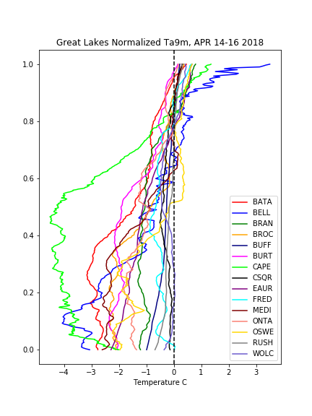persistent among sites in similar regions. A selection of these are presented here as Fig 14.

Fig 14. Normalized time (Y axis) vs temperature for the North Plateau (left), Central Lakes (middle), and Great Lakes (right) regions during the April 14 – 16 2018 freezing rain event

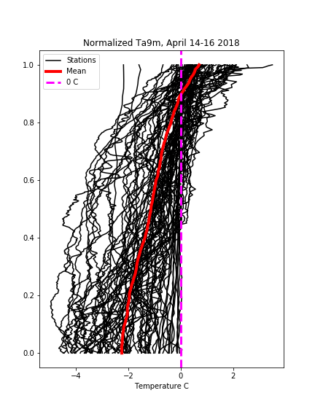From these plots, a very clear warming trend is seen as indicated by the sloping of the temperatures to the right with time. This was hinted at in the seasonal average as well, except in these cases it is very clear that temperatures pulled during freezing rain events show warming as icing conditions lift. Plotting the average profile during this freezing rain event shows that across the entire state this warming trend was seen (Fig 15). This warming trend directly indicates that NYSM freezing rain measurements capture the start of icing conditions as well as the duration that ice may linger after freezing rain has stopped falling. Since the propeller wind monitor eventually must recover from icing conditions, this warming indicates the melting of ice off the propeller before it is able to re-align with wind speeds measured by the sonic anemometer.

Fig 15. Normalized time (Y axis) vs temperature for every site during the April 14 – 16 2018 freezing rain event

4.3)Eliminating False Alarms

Out of all NYSM sites that reported freezing rain during this event, only two outliers fell outside the temperature threshold previously developed. These were both Coastal region sites that reported temperatures in excess of two degrees Celsius throughout the entire event. The two sites, Bronx in NYC and Southold in Long Island, appeared to report freezing rain starting at 22 UTC on April 15 and ending at 16 UTC on April 16. Since these two sites tripped the temperature threshold, it allowed for further investigation to be done into what caused the wind speed difference between the propeller wind monitor and sonic anemometer. From Fig 16 a clear wind speed difference can be seen, however a closer look at the raw wind speed plot for that period shows that those stations were under the influence of high surface winds. One of the reasons for the redundant wind measurements from the NYSM is actually displayed here, as wind speeds increase to past 10m/s the propeller mechanically has issues due to friction in maintaining an accurate reading of wind speed. This mechanical error is what caused the wind speed difference, and at the same time it was raining at both those sites so an observer would have seen both wind speed differences and precipitation and flagged the event as freezing rain. As wind speeds slowed over both sites, it was seen that wind speed differences also shrunk, further indicating that these two sites simply experienced mechanical errors and not actual freezing rain. This shows how utilizing a temperature threshold can weed out false alarms and outliers, thus adding more rigor to the methodology.

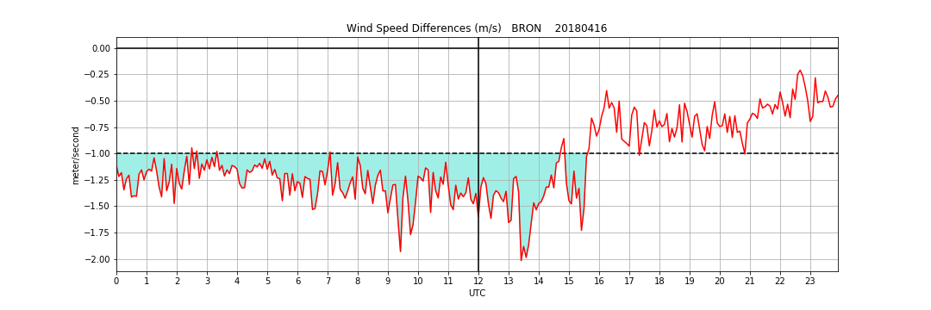

a

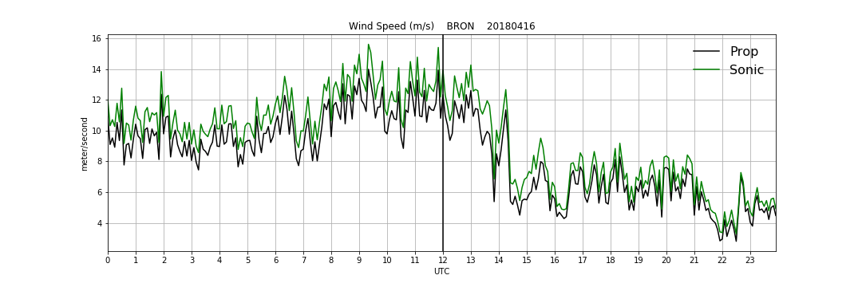

b

Fig16. a) Wind speed differences and b) raw wind speeds as reported by the Bronx NYSM site on April 16 2018

5.0)Conclusions

Ice storms pose a serious threat to both private and public property and create hazardous conditions for travel of any kind, leading to delays, closures, and other major societal impacts. These winter events have been seen to have the highest frequency in the Northeast United States, specifically in the New York area. Due to the spatial variability of freezing rain events throughout New York State, it is important to have a way of detecting these events with equal or better spatial resolution. The New York State Mesonet has been seen to have the potential to do this utilizing a new methodology which aims to turn an apparent error in data collection into a readable signal that can be interpreted both spatially and temporally without needing to add any new sensors to each and every site. By utilizing differences between the propeller wind monitor and sonic anemometer, visual observation of precipitation, and the new temperature threshold of negative five degrees Celsius to one degree Celsius, it is seen that the NYSM can detect freezing rain. By adding the temperature threshold, it was seen that a new degree of rigor could be reached, allowing for outliers to be more thoroughly analyzed and erroneous measurements to be thrown out. From the case study, it was found that NYSM freezing rain measurements can greatly improve the spatial and temporal extent of icing conditions from freezing rain. Specifically, since these measurements indicate not only the falling of freezing rain but also the longevity of icing conditions, this information can be used as a first glance at possible areas where dangerous road conditions and tree damage may be focused. This could be of use to transportation departments, insurance companies, and emergency managers within New York State. In the end, enhancing our ability to accurately indicate where ice storms are occurring and unfavorable conditions are persisting from the New York State Mesonet will help mitigate loss of property and allow the public to make more well informed decisions during such times.

5.1)Future Work

This work can still be further improved by incorporating more variables into the freezing rain algorithm from the NYSM. One of the first possible variables to be looked into next may be precipitation data. If a site meets the previous requirements for a freezing rain event but is seen to not be reporting any form of precipitation, that site may actually just be experiencing a mechanical error that is not related to freezing rain at all. At the same time though, it could also be a freezing drizzle instead where precipitation is not hard enough to measure but enough to accumulate ice on the propeller wind monitor. Either way, this may be good to look at next.

Another import aspect of the NYSM that should be incorporated into this work is the profiler network. As the largest and most advanced vertical profiler network in the world, the NYSM profiler network should be used to verify freezing rain profiles at sites that coexist with the profiler sites during freezing rain events. Utilizing the microwave radiometer and LiDAR, virtual vertical soundings can be generated every five minutes, meaning the formation, duration, and recession of freezing rain vertical conditions could be seen in virtually real time. This process would be a huge step towards verifying NYSM freezing rain measurements and add a major boost to confidence to the process.

Acknowledgements:

This work could not have been done without the help of all the staff at the NYSM. Without the help of field technicians physically going to sites and witnessing freezing conditions and staff in the operations center noticing this pattern, this project would not have been possible. Special thanks to Dr. Junhong (June) Wang for her direct assistance in advising this project.

References

* DeGaetano AT. 2000. Climatic perspective and impacts of the 1998 northern New York and New England ice storm. *Bull.* *Am. Meteorol. Soc.* **81**: 237–254, doi: 10.1175/1520-0477(2000)081*<*0237:CPAIOT*>*2.3.CO;2.
* Degelia, Samuel K., et al. “An Overview of Ice Storms and Their Impact in the United States.” *International Journal of Climatology*, vol. 36, no. 8, 2015, pp. 2811–2822., doi:10.1002/joc.4525.
* Kovacik, C., and K. Kloesel, 2014: Changes in Ice Storm Frequency Across the United States. Southern Climate Impacts Planning Program, 21 pp.
* NCEI, 2019 “Storm Events Database.” *National Centers for Environmental Information*, National Oceanic and Atmospheric Administration, [www.ncdc.noaa.gov/stormevents/](http://www.ncdc.noaa.gov/stormevents/).
* Rauber RM, Olthoff LS, Ramamurthy MK, Miller D, Kunkel KE. 2001. A synoptic weather pattern and sounding-based climatology of freezing precipitation in theUnited States East of the Rocky mountains. J. Appl. Meteorol. Climatol. 40: 1724–1747, doi: 10.1175/1520-0450(2001)040<1724:ASWPAS>2.0.CO;2.
* United States, Congress, “Automated Surface Observing System: ASOS User's Guide.” *Automated Surface Observing System: ASOS User's Guide*, U.S. Dept. of Commerce, National Oceanic and Atmospheric Administration, 1998.